# Technical FAQ (about software testing)

## Best practice for using assert() in test code

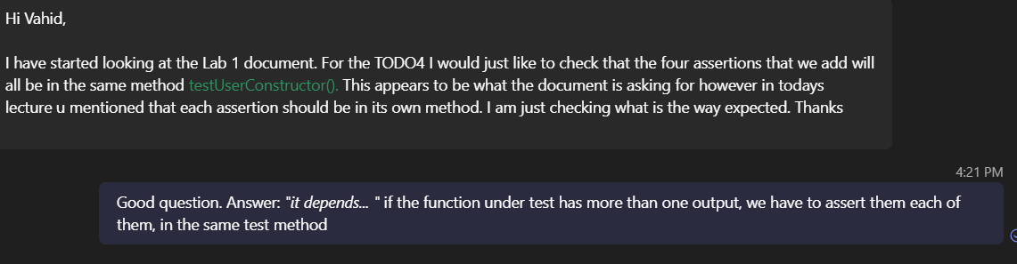We are not saying that a test method should not have multiple assertions. It can have and it’s not a problem if the above is the case (if all asserts belong to one single test case). But several test cases should not be combined into one test method.

## Can we use JUnit assertEquals() instead of regular asserts? No!

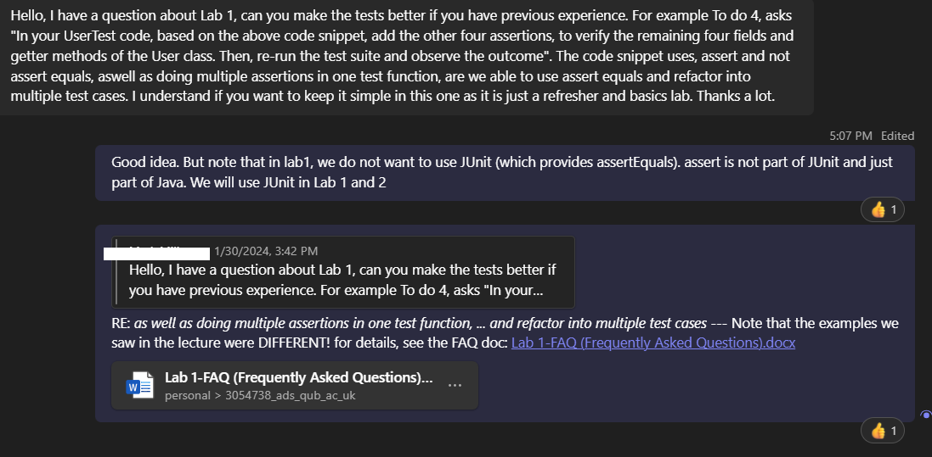

# Non-technical FAQ (Project set-up, etc)

## *“I was wondering if we could use [the] IntelliJ [IDE] for the lab assignment?”*

Answer: There is a section in the lab document about this issue.

## GitHub repository set up

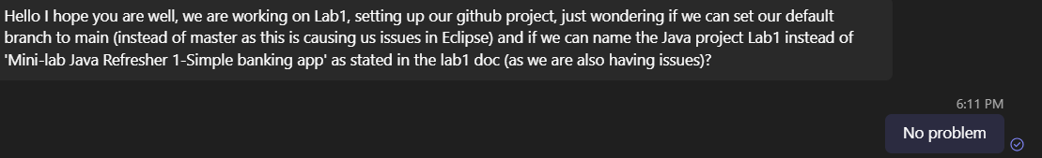

## Can we use any email address for our GitHub accounts?

Obviously yes